Install the soccer robot

Step 1
Remove two photoresistors | 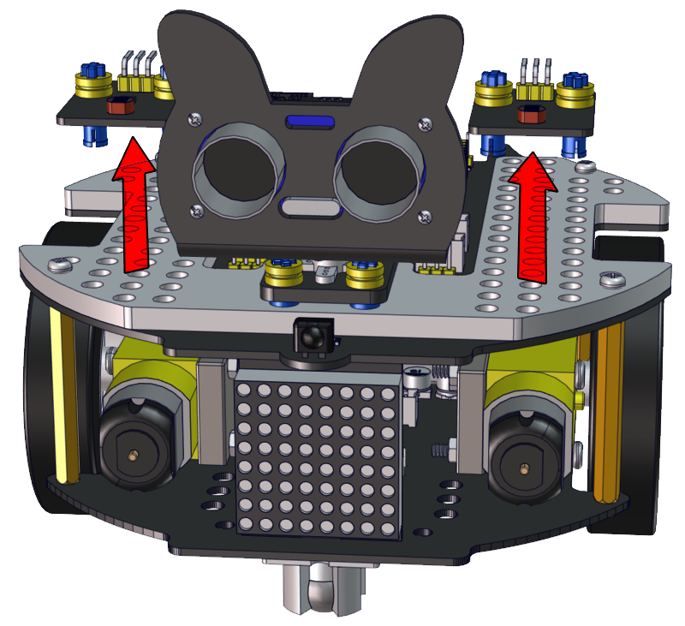
Required Parts | 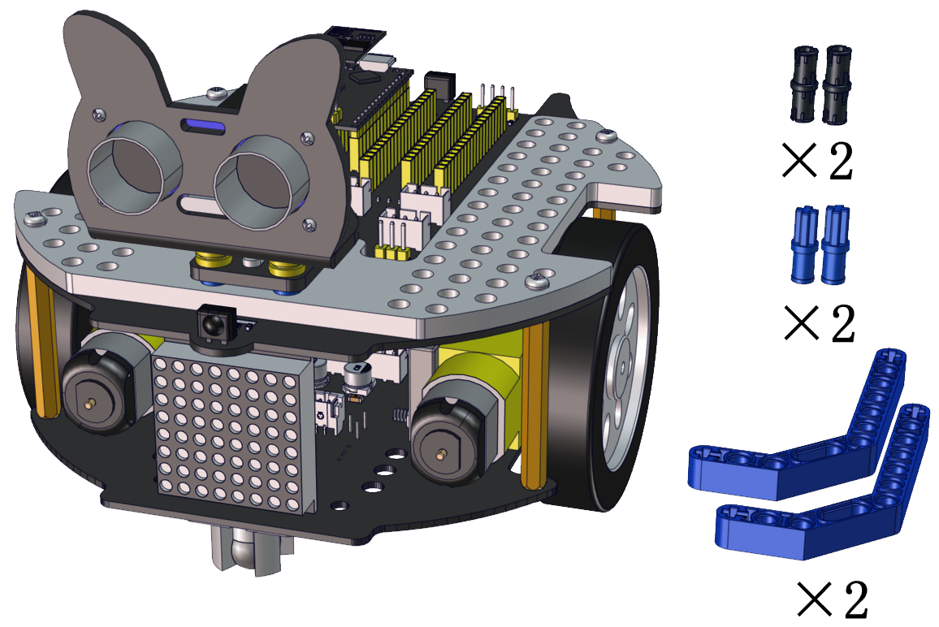

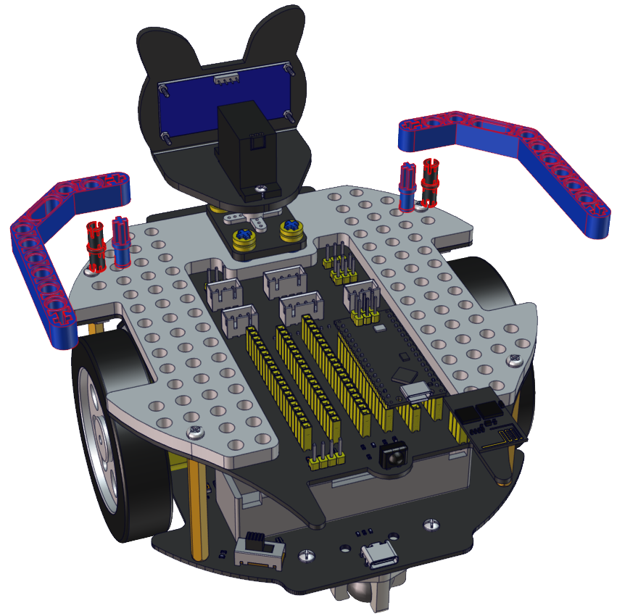

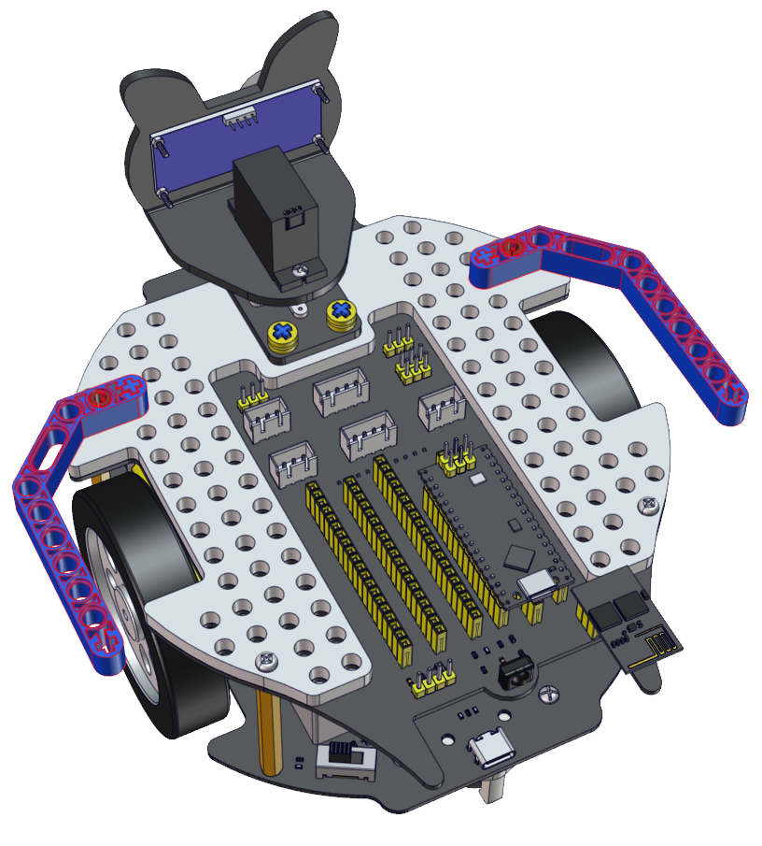

Step 2
Required Parts | 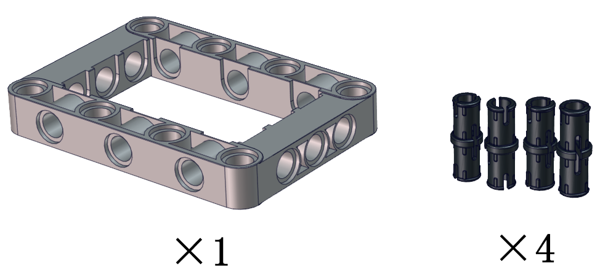

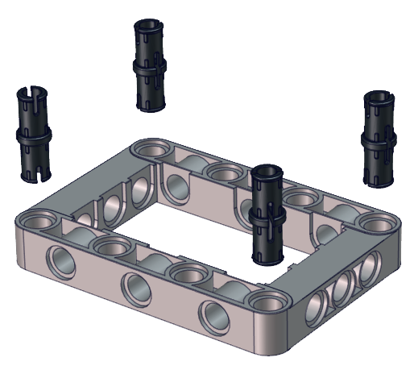

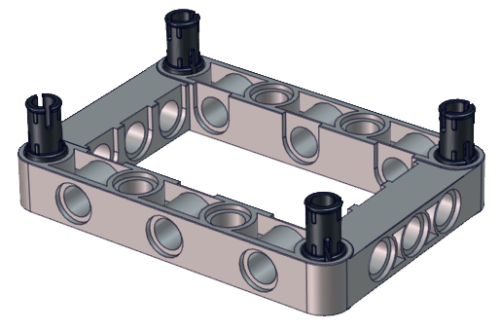

Step 3
Required Parts | 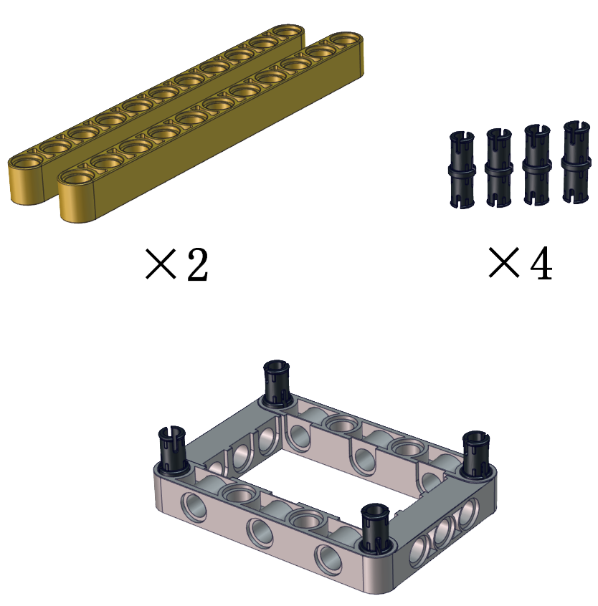

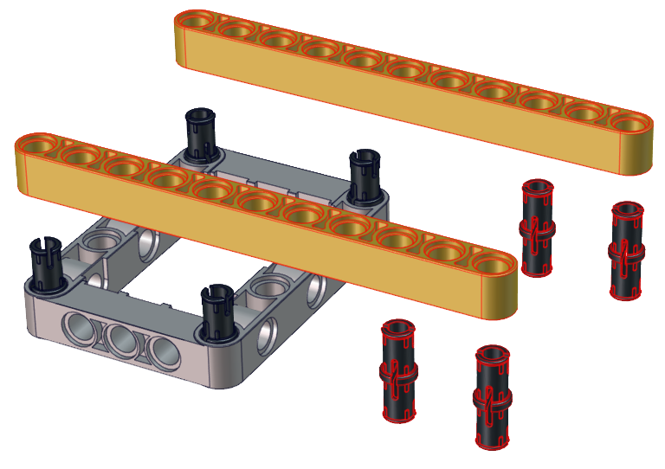

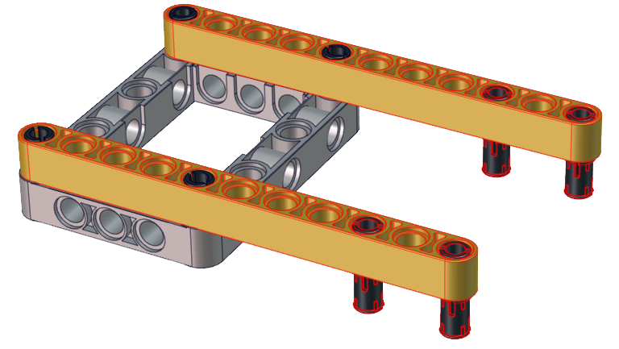

Step 4
Required Parts | 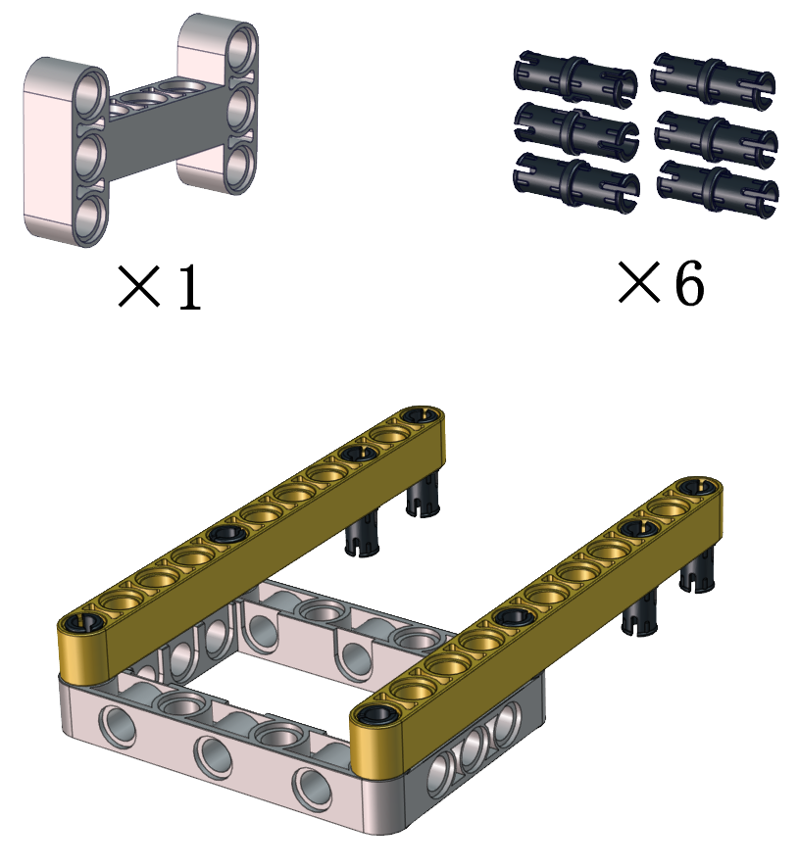

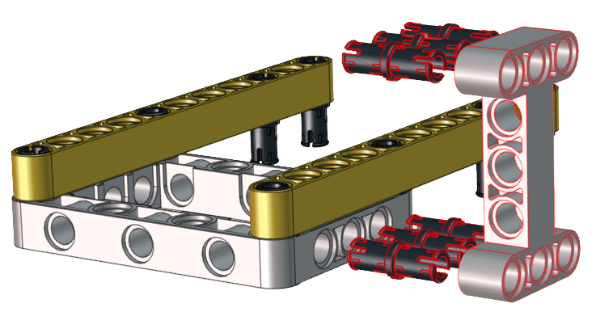

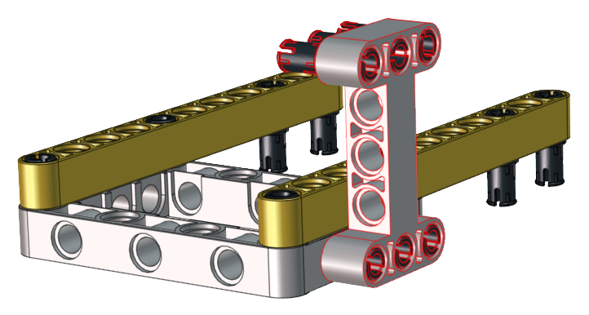

Step 5
Required Parts | 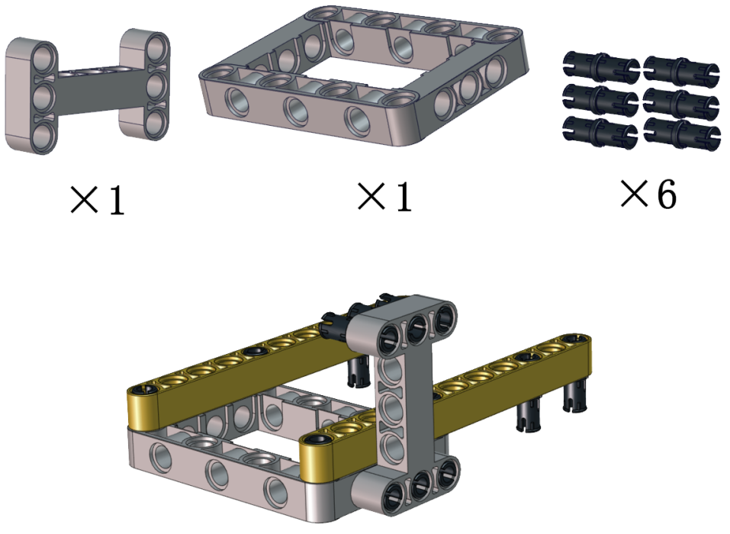

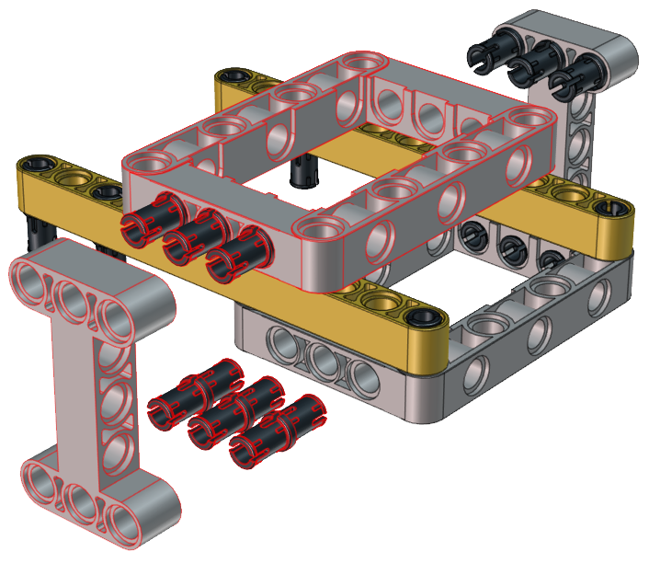

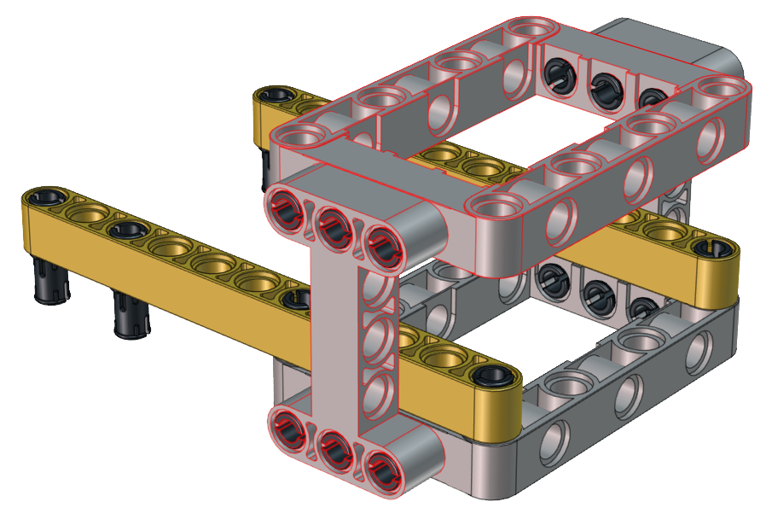

Step 6
Required Parts | 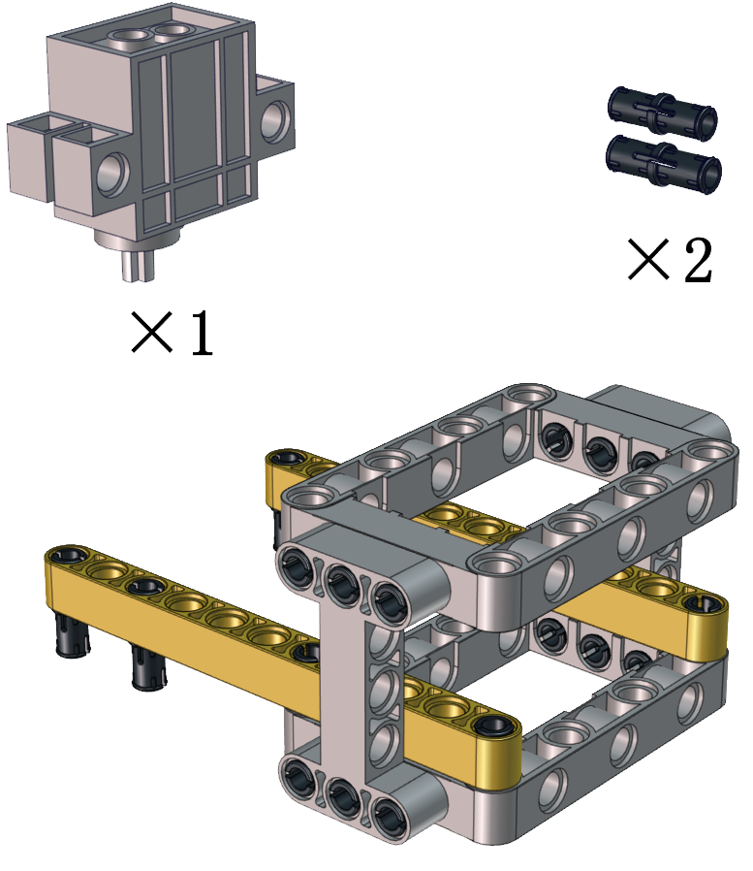
Note the installation direction of the part marked by the red circle

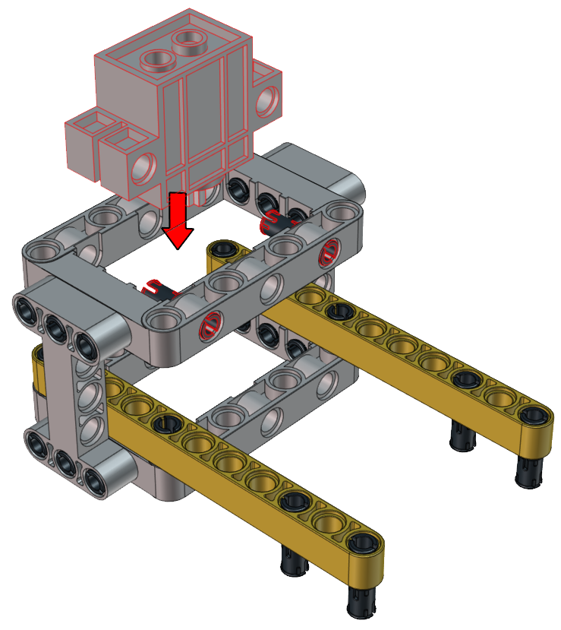

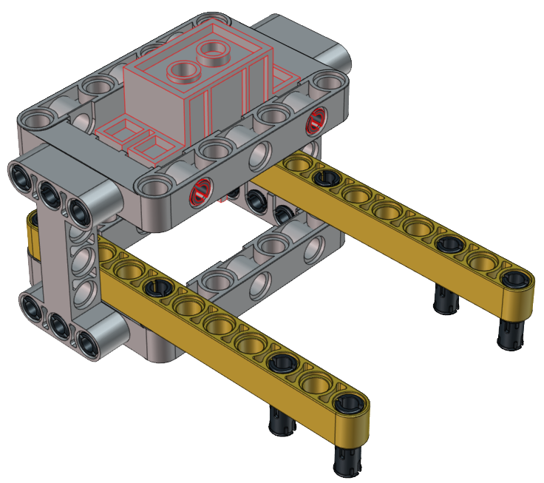

Step 7
Required Parts | 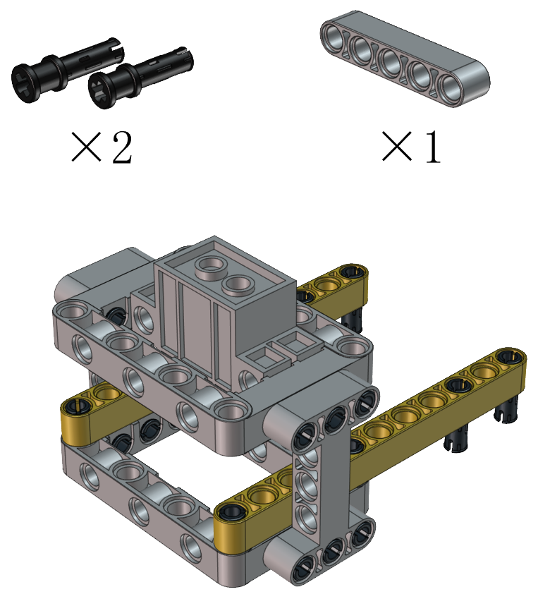

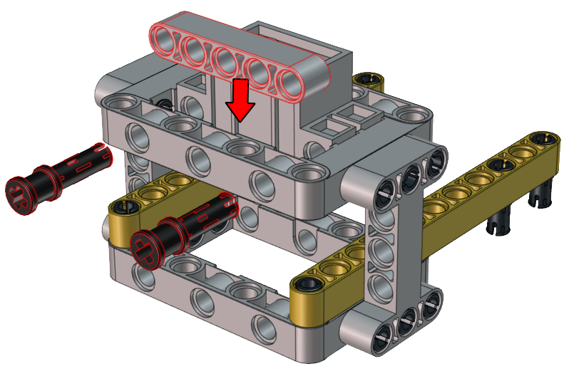

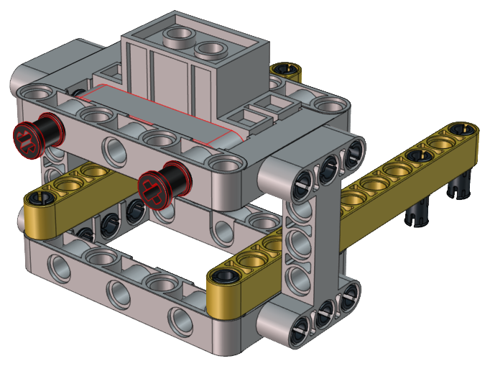

Step 8
Required Parts | 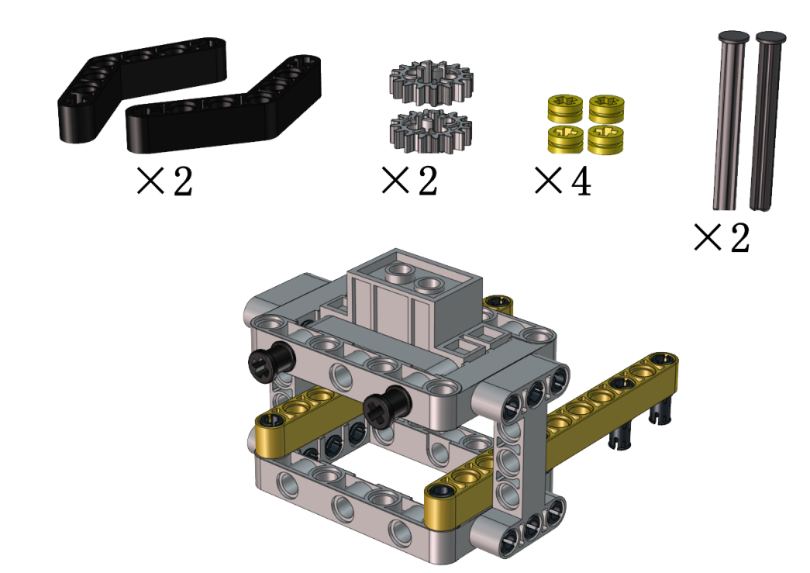
Adjust the angle of the claw. Then make it close and face front

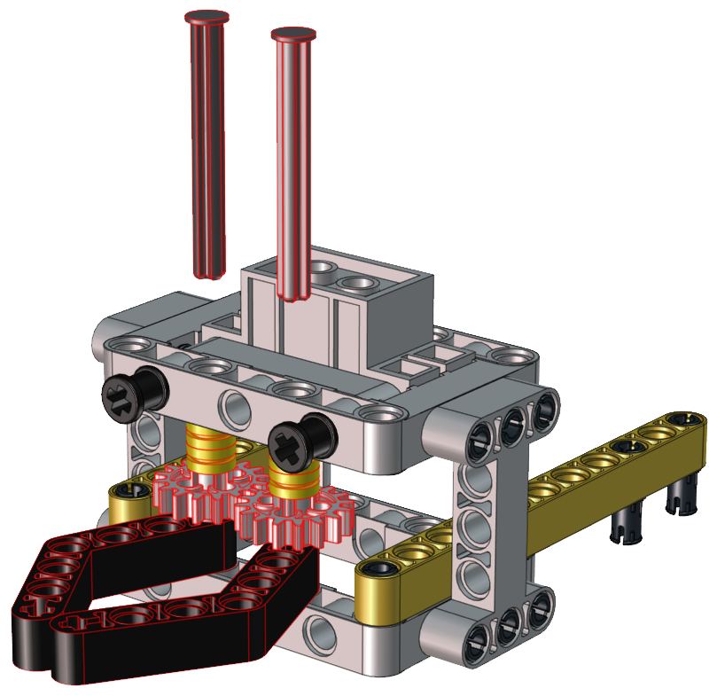

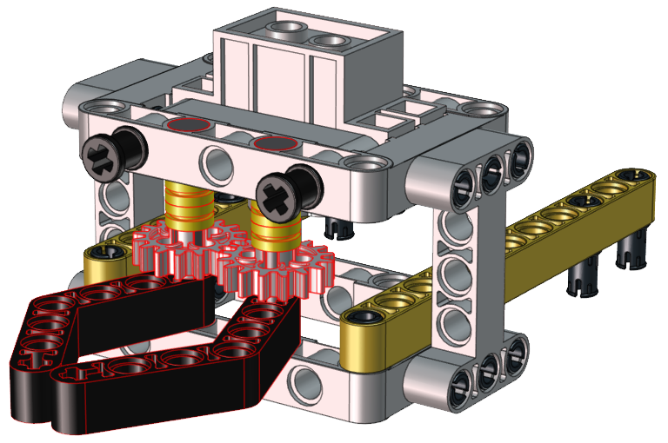

Step 9
Required Parts | 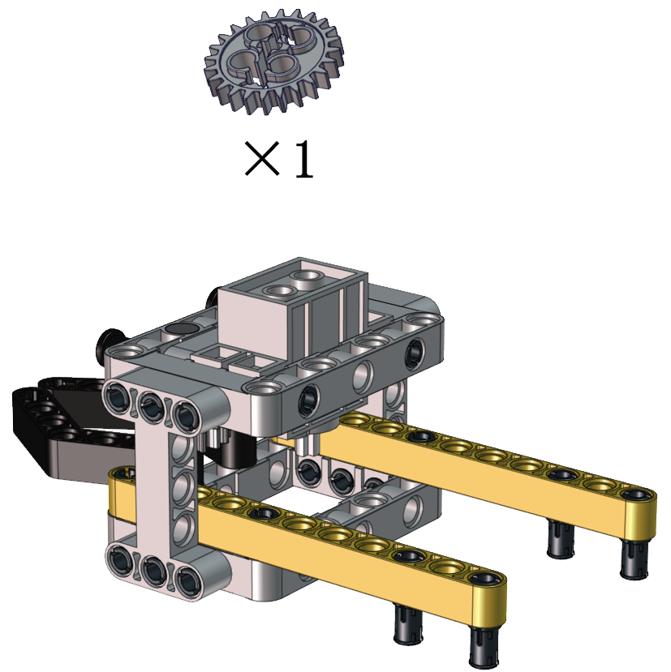
Set the angle of the servo to 180 degree | Wire Up  //*********************************************************************  #include <Arduino.h>  //Servo channels  int channel_PWM = 4;  // Servo frequency, then the period is 1/50, which is 20ms, PWM has a total of 16 channels, 0-7 high-speed channels are driven by 80Mhz clock, and the last 8 low-speed channels are driven by 1Mhz clock.  int freq_PWM = 50;  // PWM resolution, the value is between 0-20, here is 10, then the pwm value filled in the following ledcWrite is between 0-2 to the 10th power, that is, 0-1024.  int resolution_PWM = 10;  //  const int PWM_Pin = 23; //connect pwm to GPIO23 output.  void setup() {  ledcSetup(channel_PWM, freq_PWM, resolution_PWM); // Set servo channel, servo frequency, PWM resolution..  ledcAttachPin(PWM_Pin, channel_PWM); //  }  void loop() {  ledcWrite(channel_PWM, 128); //The 20ms high level is about 2.5ms, which is 2.5/20*1024, and the angle of the steering gear is 180°.  .  }  //*********************************************************************  Upload the code of the servo to the main board of the Beetlebot car, as shown below  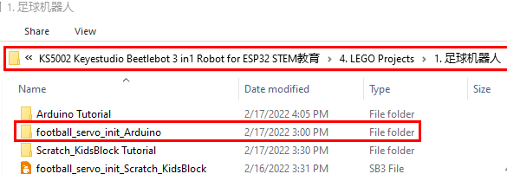  You can also initialize the angle of the servo through the following code  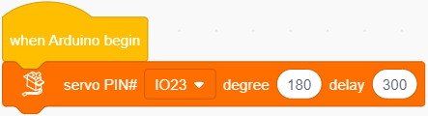  Check the Scratch-KidsBlock code as follows，then upload the code to the main board of the Beetlebot car  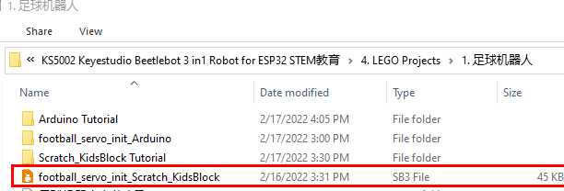
  Servo | PCB Board
  Brown | G
  Red | 5V
  Orange | S2（GPIO23）
Keep the claw close and face front before installing the gear | 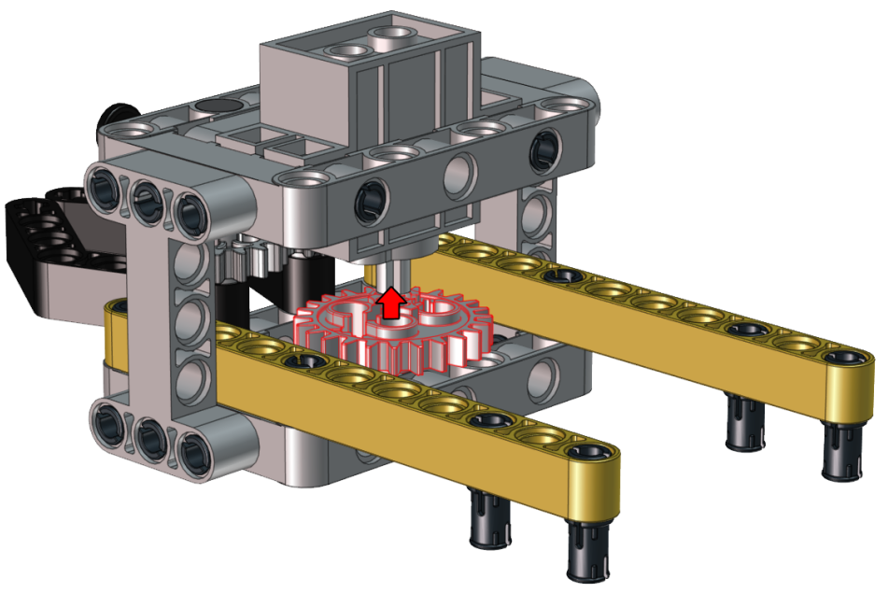
 | 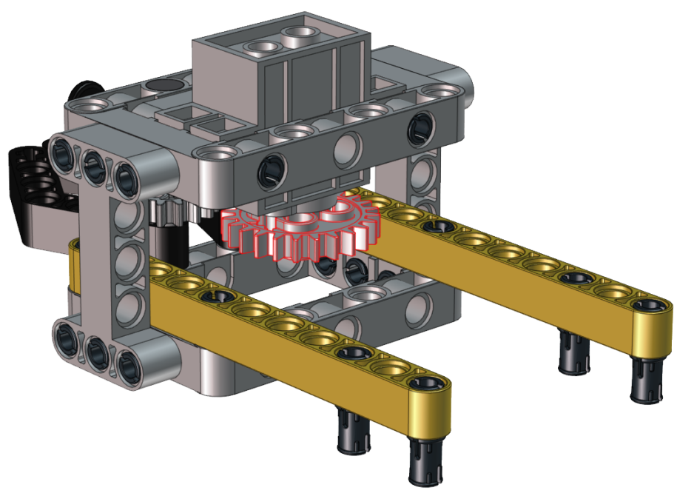

Step 10
Required Parts | 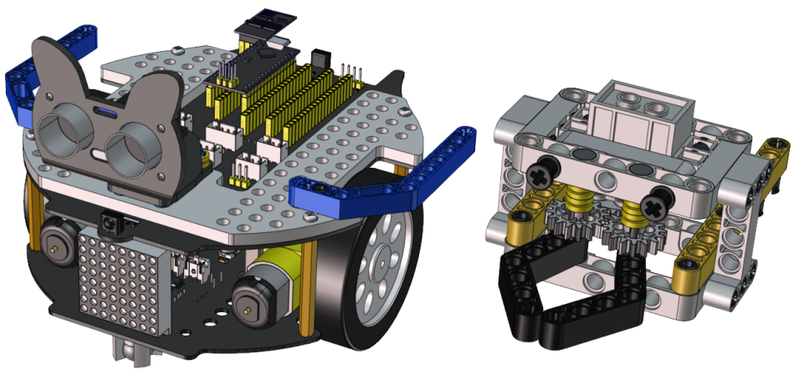

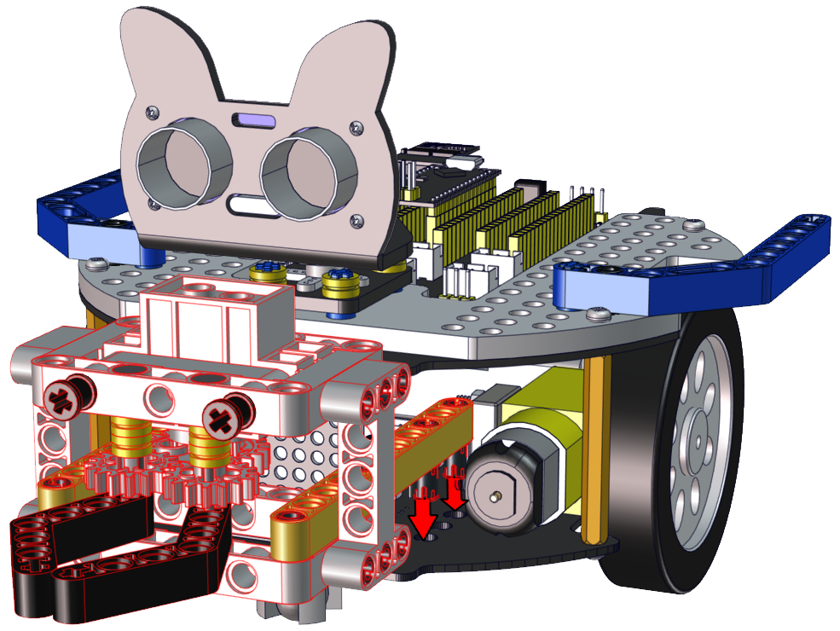

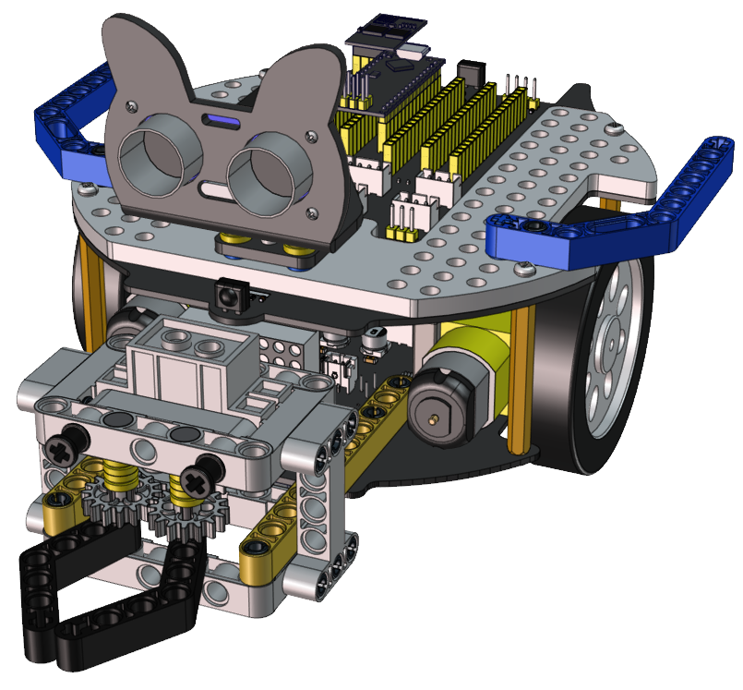

Step 11
Required Parts | 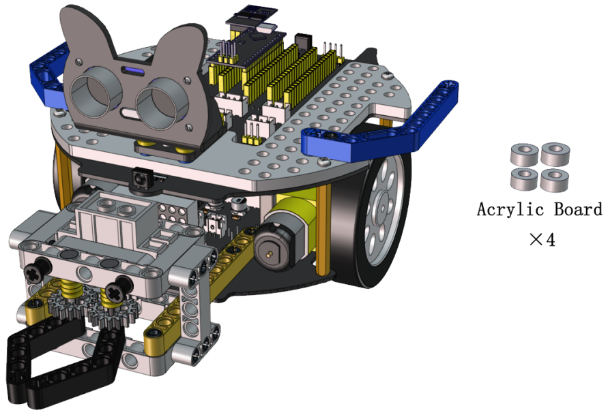

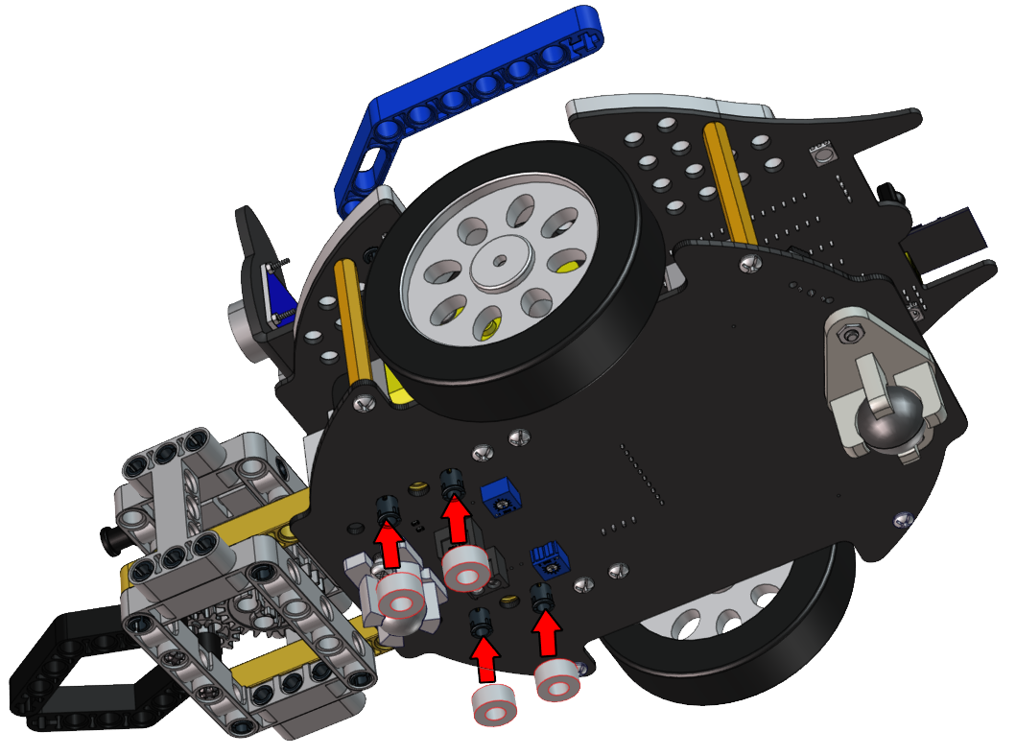

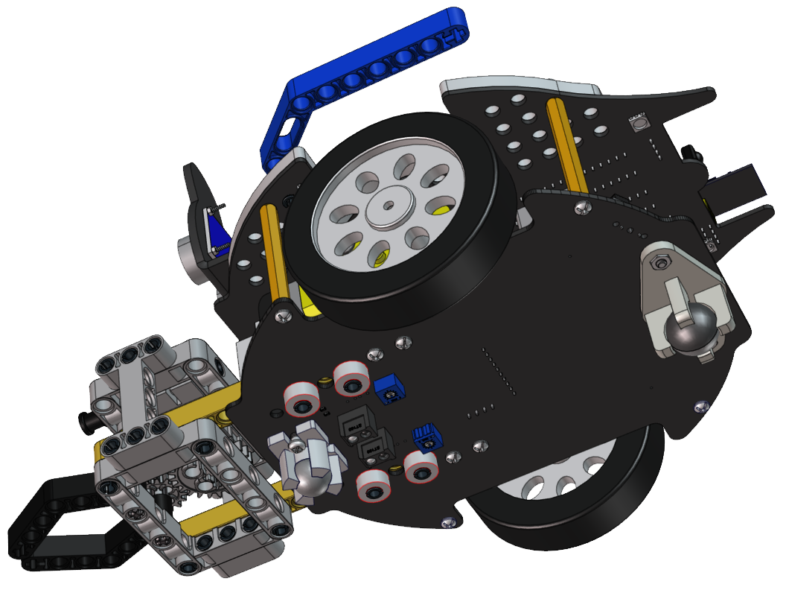

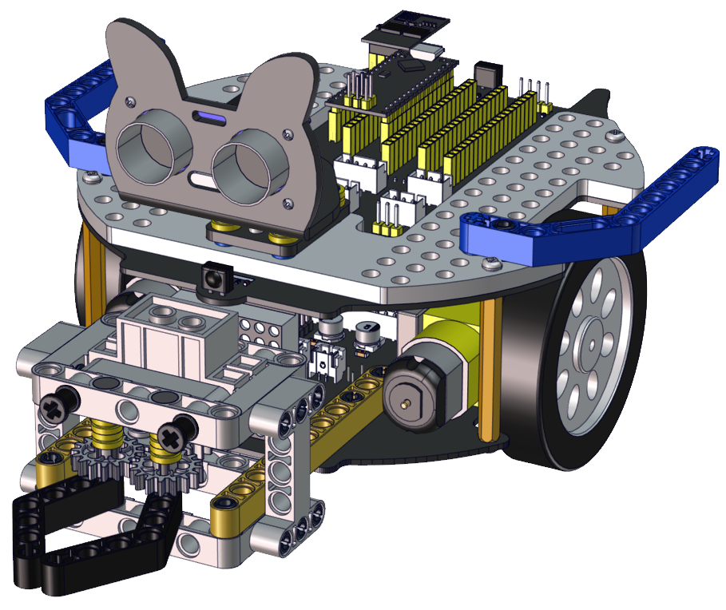

Wiring Diagram
Wire up the LEGO servo | 

